Date | 28.09.2026
Team ID | SWTID-2026-6482
Project name | Auto Ticket Classification using Flow Designer

Ideation phase-I

1. Brainstorm & Idea Prioritization

1.1 Brainstorming - Divergent Thinking
Theme 1 - Rules: Keyword-based routing, Regex patterns
Theme 2 - AI/ML: TF-IDF + NB, BERT, Predictive Intelligence, LLM API, Sentiment escalation
Theme 3 - Automation UX: Flow Designer trigger, Email-to-ticket parser, Virtual Agent, KB suggestion, Dashboard feedback loop
S.No | Idea Generated | Description
1 | Keyword-based Auto Routing | Simple rule: IF contains 'password, login' THEN IAM Team
2 | ML Model Classification | Train NLP model on historical tickets to predict Category / Group
3 | Predictive Intelligence in ServiceNow | Use ServiceNow OOB Predictive Intelligence
4 | LLM / Generative AI Classification | Use BERT / GPT API to understand ticket intent
5 | Flow Designer No-Code Automation | Build automated flow triggered on ticket creation
6 | Priority Prediction Engine | Predict P1-P4 based on impact + urgency keywords
7 | Auto KB Suggestion | Suggest relevant Knowledge Base article while classifying
8 | Sentiment Based Escalation | Detect angry / urgent tone and auto-escalate

1.2 Idea Prioritization Matrix

Framework: Impact vs Effort. Scale: High/Medium/Low
Idea | Impact | Effort | Priority
ML Model Classification | High | Medium | P0 - Must Have
Flow Designer Automation | High | Low | P0 - Must Have
Predictive Intelligence OOB | High | Low | P0 - Must Have
Priority Prediction Engine | High | Medium | P1 - Should Have
Keyword-based Routing | Medium | Low | P1
Auto KB Suggestion | Medium | Medium | P2 - Good to Have
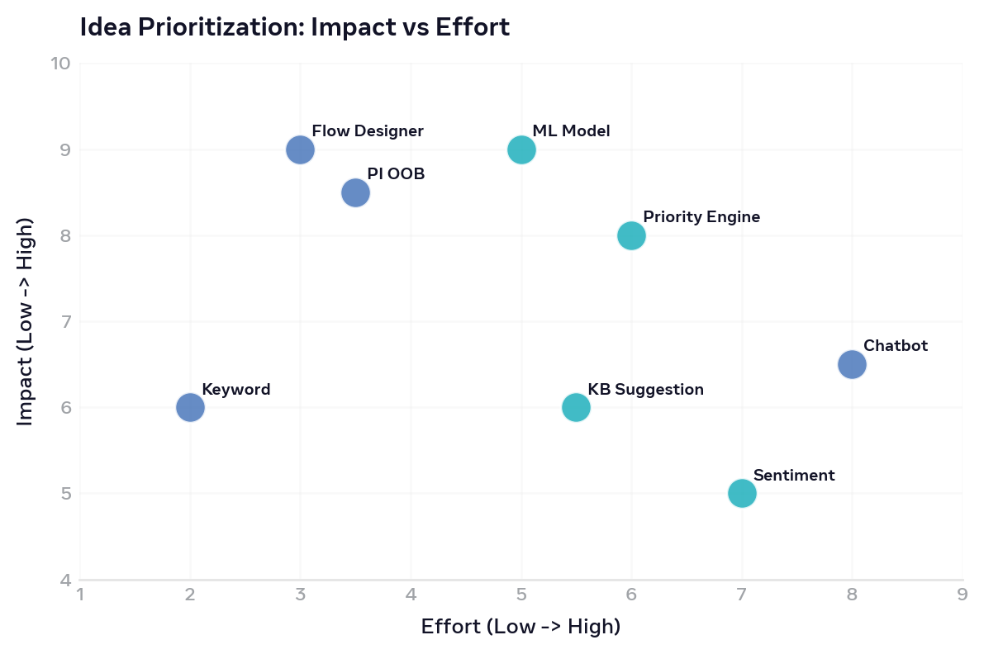
Figure: Impact vs Effort - Flow Designer is High Impact Low Effort, hence selected for MVP

Final Selected Ideas for MVP
1. Flow Designer Trigger on Incident Creation
2. NLP Model (TF-IDF + NB / BERT) for Category, Sub-category, Assignment Group
3. Priority Prediction Logic
4. Fallback to Manual Triage if confidence < 60%

